City of Valley Falls

January 3rd, 2021

Dear Mayor and Council Members:

SUBJECT: Valley Falls Financial status

BACKGROUND:

Every month, I provide the governing body with a brief status update regarding City finances. Please review the following information, which provides more history and clarification on certain items.

Revenue:

TOTAL Sales TAX DEPOSIT | 2015 | 2016 | % Change | 2017 | % Change | 2018 | % Change | 2019 | % Change | 2020 | % Change | 2021 | % Change | Average % change
January | $13,402 | $12,896 | -3.92% | $14,399 | 10.44% | $24,672 | 41.64% | $34,319 | 28.11% | $26,969 | -27.25% | $34,286 | 27.13% | 9.80%
February | $14,923 | $14,081 | -5.98% | $15,627 | 9.89% | $24,815 | 37.03% | $22,719 | -9.23% | $24,985 | 9.07% |  |  | 8.16%
March | $12,916 | $14,043 | 8.03% | $22,668 | 38.05% | $25,728 | 11.89% | $25,967 | 0.92% | $27,295 | 4.87% |  |  | 12.75%
April | $12,200 | $12,438 | 1.91% | $18,291 | 32.00% | $24,206 | 24.44% | $25,974 | 6.81% | $20,984 | -23.78% |  |  | 8.28%
May | $14,226 | $15,024 | 5.31% | $24,201 | 37.92% | $22,104 | -9.49% | $25,051 | 11.76% | $37,112 | 32.50% |  |  | 15.60%
June | $12,350 | $14,580 | 2.43% | $28,488 | 48.82% | $27,657 | -3.00% | $23,738 | -16.51% | $32,889 | 27.82% |  |  | 11.91%
July | $16,847 | $14,429 | -16.76% | $26,361 | 45.26% | $23,039 | -14.42% | $22,617 | -1.87% | $31,899 | 29.10% |  |  | 8.26%
August | $14,706 | $13,942 | -5.48% | $21,593 | 35.43% | $21,313 | -1.31% | $24,090 | 11.53% | $36,831 | 34.59% |  |  | 14.95%
September | $13,716 | $14,934 | 8.15% | $26,767 | 44.21% | $23,401 | -14.38% | $31,217 | 25.04% | $29,686 | -5.16% |  |  | 9.64%
October | $13,409 | $14,758 | 9.14% | $26,239 | 43.76% | $21,483 | -22.14% | $24,905 | 13.74% | $32,290 | 22.87% |  |  | 13.47%
November | $14,511 | $14,533 | 0.15% | $26,993 | 46.16% | $22,210 | -21.54% | $26,384 | 15.82% | $27,149 | 2.82% |  |  | 8.68%
December | $14,995 | $16,126 | 7.02% | $26,529 | 39.21% | $21,206 | -25.10% | $22,557 | 5.99% | $28,985 | 22.18% |  |  | 9.86%
Total | $168,200 | $171,783 | 2.09% | $278,156 | 38.24% | $281,834 | 1.30% | $309,538 | 8.95% | $357,075 | 13.31% | $34,286 | -90.40% | 12.78%
Average | $14,017 | $14,315 | 2.09% | $23,180 | 35.93% | $23,486 | 0.30% | $25,795 | 7.68% | $29,756 | 10.80% |  |  | 11.36%

TOTAL PROPERTY TAX DEPOSIT | 2015 | 2016 | % Change | 2017 | % Change | 2018 | % Change | 2019 | % Change | 2020 | % Change | 2021 | % Change | Average % change
January | $103,778 | $108,379 | 4.25% | $114,902 | 5.68% | $116,959 | 1.76% | $117,495 | 0.46% | $147,221 | 20.19% | $141,003 | -4.22% | 4.68%
February
March | $13,052 | $12,066 | -8.17% | $10,603 | -13.80% | $8,144 | -30.20% | $13,723 | 40.65% | $8,830 | -55.41% |  |  | -13.38%
April
May | $74,604
June |  | $80,199 | 6.98% | $76,374 | -5.01% | $75,083 | -1.72% | $90,971 | 17.47% | $100,869 | 9.81% |  |  | 5.51%
July
August
September | $25,301 | $21,447 | -17.97% | $31,571 | 32.07% | $26,707 | -18.21% | $20,181 | -32.34% | $24,891 | 18.92% |  |  | -2.92%
October | $6,052 | $2,778 | -117.86% | $2,471 | -12.43% | $2,939 | 15.93% | $4,520 | 34.96% | $2,881.15 | -56.87% |  |  | -27.25%
November
December
Total | $222,787 | $224,869 | 0.93% | $235,921 | 4.68% | $229,832 | -2.65% | $246,890 | 6.91% | $284,692 | 13.28% | $141,003 |  | 4.63%
Average | $44,557 | $44,974 |  | $47,184 |  | $45,966 |  | $49,378 |  | $56,938

Bank Balance:

The most important number that the City must monitor is the actual cash on hand balance, which is reflected in our banking institution. Please refer to the following image which demonstrates the bank balance from 2016 to December 2020.

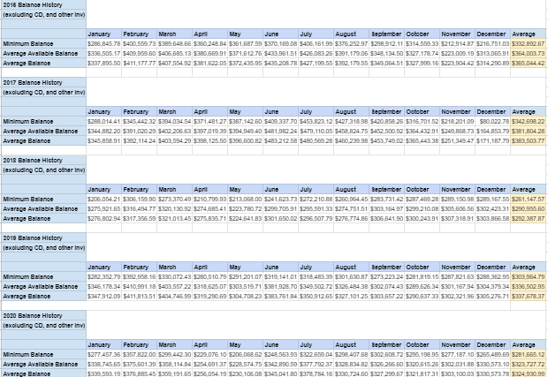

As you will see, the final average balance number in 2020 ($324,930.99), has declined from its high in 2017 of $383,503.77 a decline of 15 percent, and is up from the low in 2018 of $292,387.87, an increase of 10%.

This number flows up and down over time, depending on what major expenses the City absorbs.

Fund Balance:

The City operates utilizing twelve funds. Each fund has requirements for how it can be utilized. Please refer to the chart below, which demonstrates the fund balance from each fund since 2016.

Month (End Balance) | General | Water | Sewer | Capital Improvement | Consolidated Streets and Highway | Special Equipment Reserve | Solid Waste | Bond and Interest | RHID | All Funds
January 2016 | $257,124 | $98,194 | $244,194 | $0 | $324,112 | $10,369 | $74,294 | $0 |  | $1,008,286
February 2016 | $247,491 | $108,237 | $250,379 | $0 | $324,112 | $10,369 | $68,761 | $0 |  | $1,009,348
March 2016 | $244,887 | $106,711 | $248,717 | $0 | $324,112 | $10,369 | $76,061 | $0 |  | $1,010,251
April 2016 | $213,162 | $103,275 | $245,715 | $0 | $331,400 | $10,369 | $76,333 | $0 |  | $980,255
May 2016 | $203,564 | $108,520 | $247,782 | $0 | $331,400 | $10,369 | $69,473 | $0 |  | $971,109
June 2016 | $256,253 | $115,709 | $250,496 | $0 | $331,400 | $10,369 | $77,143 | $0 |  | $1,041,370
July 2016 | $224,029 | $105,328 | $250,155 | $0 | $338,978 | $10,369 | $77,101 | $0 |  | $1,005,960
August 2016 | $202,781 | $107,960 | $230,225 | $0 | $338,978 | $10,369 | $77,690 | $0 |  | $967,627
September 2016 | $177,473 | $113,452 | $231,807 | $0 | $328,928 | $10,369 | $77,487 | $0 |  | $939,206
October 2016 | $309,719 | $122,355 | $236,787 | $1,296,405 | $337,161 | $10,369 | $78,407 | $0 |  | $2,391,141
November 2016 | $29,229 | $128,059 | $238,965 | $1,285,841 | $337,161 | $10,369 | $78,102 | $153,500 |  | $2,258,959
December 2016 | $114,623 | $134,362 | $245,996 | $1,447,725 | $332,136 | $10,369 | $79,188 | $153,721 |  | $2,518,118
January 2017 | $217,132 | $122,270 | $249,870 | $1,382,890 | $339,946 | $10,369 | $72,485 | $153,721 |  | $2,468,412
February 2017 | $199,343 | $129,417 | $254,262 | $1,382,890 | $339,946 | $10,369 | $79,971 | $153,721 |  | $2,549,856
March 2017 | $192,459 | $135,086 | $258,255 | $1,317,890 | $339,946 | $10,369 | $66,650 | $162,836 |  | $2,481,954
April 2017 | $167,406 | $124,010 | $253,508 | $1,318,579 | $347,139 | $10,369 | $66,752 | $169,998 |  | $2,457,760
May 2017 | $157,482 | $131,040 | $255,342 | $1,301,353 | $345,327 | $10,369 | $66,955 | $179,788 |  | $2,447,656
June 2017 | $216,337 | $137,217 | $260,204 | $1,284,946 | $343,652 | $10,369 | $67,015 | $191,602 |  | $2,511,343
July 2017 | $195,129 | $129,202 | $264,452 | $1,222,926 | $347,533 | $10,369 | $66,706 | $202,593 |  | $2,438,910
August 2017 | $176,522 | $140,076 | $264,246 | $1,159,722 | $327,308 | $10,369 | $66,855 | $211,212 |  | $2,356,311
September 2017 | $203,369 | $143,470 | $268,370 | $1,031,655 | $324,214 | $10,369 | $66,386 | $180,732 |  | $2,228,564
October 2017 | $190,527 | $147,426 | $271,247 | $940,959 | $202,520 | $10,369 | $66,318 | $191,394 |  | $2,020,760
November 2017 | $181,731 | $155,818 | $273,947 | $799,367 | $94,708 | $10,369 | $66,212 | $201,966 |  | $1,784,117
December 2017 | $200,678 | $162,983 | $278,996 | $627,828 | $98,170 | $10,369 | $80,403 | $213,070 |  | $1,672,497
January 2018 | $273,901 | $153,730 | $282,875 | $343,170 | $55,412 | $10,369 | $78,776 | $223,094 |  | $1,422,163
February 2018 | $259,249 | $154,759 | $287,410 | $267,704 | $54,529 | $10,369 | $80,114 | $233,146 |  | $1,348,140
March 2018 | $252,651 | $160,451 | $290,675 | $202,085 | $54,529 | $10,369 | $80,176 | $182,033 |  | $1,233,829
April 2018 | $232,010 | $156,382 | $259,221 | $125,185 | $61,619 | $10,369 | $80,196 | $191,967 |  | $1,117,809
May 2018 | $215,938 | $164,367 | $262,540 | $182,224 | -$39,394 | $10,369 | $81,108 | $200,798 |  | $1,078,809
June 2018 | $274,605 | $163,634 | $266,117 | -$3,659 | -$53,408 | $10,369 | $81,053 | $212,141 |  | $951,712
July 2018 | $234,576 | $155,855 | $270,388 | -$3,169 | -$46,906 | $10,369 | $80,962 | $217,185 |  | $920,118
August 2018 | $217,377 | $167,575 | $274,955 | -$3,100 | -$47,475 | $10,369 | $80,819 | $225,564 |  | $926,943
September 2018 | $240,121 | $178,897 | $280,660 | -$3,000 | -$52,297 | $10,369 | $81,426 | $212,204 |  | $949,240
October 2018 | $216,568 | $180,275 | $281,591 | -$2,903 | -$39,518 | $10,369 | $80,848 | $220,570 |  | $947,800
November 2018 | $185,787 | $185,283 | $285,283 | -$2,803 | -$30,720 | $10,369 | $80,818 | $229,368 |  | $943,384
December 2018 | $146,032 | $194,280 | $288,895 | $385 | $0 | $10,369 | $54,869 | $237,723 |  | $932,552
January 2019 | $239,547 | $185,520 | $294,604 | $739 | $14,668 | $11,319 | $55,361 | $252,391 |  | $1,054,148
February 2019 | $210,426 | $184,357 | $298,999 | $1,106 | $23,580 | $11,319 | $55,853 | $261,303 |  | $1,046,610
March 2019 | $207,426 | $188,664 | $304,757 | $1,437 | $34,380 | $11,319 | $55,669 | $185,564 |  | $989,215
April 2019 | $163,196 | $176,383 | $297,810 | $1,803 | $45,281 | $11,319 | $55,310 | $196,465 |  | $947,566
May 2019 | $142,047 | $181,022 | $298,902 | $2,158 | $55,232 | $11,319 | $55,245 | $205,416 |  | $951,341
June 2019 | $190,357 | $186,576 | $285,402 | $2,524 | $64,863 | $11,319 | $55,162 | $215,047 |  | $1,010,676
July 2019 | $167,418 | $186,384 | $267,856 | $2,879 | $73,832 | $11,319 | $55,733 | $224,017 |  | $999,100
August 2019 | -$49,679 | $361,007 | $258,661 | $3,245 | $84,094 | $11,319 | $55,316 | $234,278 |  | $958,240
September 2019 | -$83,175 | $366,284 | $264,247 | $3,612 | $96,453 | $11,319 | $55,301 | $225,488 |  | $939,528
October 2019 | -$95,555 | $364,463 | $268,678 | $3,967 | $96,453 | $11,319 | $56,327 | $235,980 |  | $929,669
November 2019 | -$116,018 | $370,163 | $273,664 | $4,333 | $96,453 | $11,319 | $55,612 | $246,727 |  | $942,252
December 2019 | $39,168 | $179,970 | $281,000 | $4,688 | $96,453 | $11,319 | $47,310 | $255,934 |  | $915,842
January 2020 | $154,828 | $174,466 | $273,156 | $5,054 | $96,453 | $5,656 | $55,472 | $267,254 |  | $1,032,338
February 2020 | $128,559 | $179,535 | $278,938 | $5,421 | $96,453 | $5,656 | $55,314 | $277,055 |  | $1,026,930
March 2020 | $117,603 | $180,542 | $282,612 | $5,764 | $96,453 | $5,656 | $55,570 | $201,724 |  | $945,924
April 2020 | $55,972 | $166,170 | $276,388 | $5,764 | $103,906 | $5,656 | $55,880 | $209,882 |  | $879,619
May 2020 | $49,402 | $168,167 | $283,568 | $6,485 | $103,906 | $5,656 | $54,753 | $225,024 |  | $896,962
June 2020 | $162,311 | $174,330 | $290,715 | $6,485 | $113,139 | $5,656 | $54,353 | $238,658 |  | $1,045,647
July 2020 | $118,220 | $185,964 | $290,056 | $7,207 | $93,123 | $5,656 | $55,108 | $251,642 |  | $1,006,254
August 2020 | $63,875 | $198,575 | $296,235 | $7,207 | $95,478 | $5,656 | $55,101 | $267,296 |  | $989,422
September 2020 | $44,674 | $206,946 | $296,866 | $7,940 | $106,509 | $5,656 | $56,792 | $258,766 |  | $984,149
October 2020 | $22,290 | $201,269 | $302,649 | $7,940 | $77,215 | $5,656 | $56,084 | $272,192 |  | $945,295
November 2020 | $10,080 | $181,857 | $309,136 | $8,292 | $75,565 | $5,656 | $55,807 | $283,301 |  | $929,695
December 2020 | $19,646 | $256,495 | $294,863 | $8,656 | $73,365 | $5,656 | $56,343 | $295,386 |  | $1,010,411
January 2021 | $144,157 | $168,735 | $300,777 | $9,008 | $87,432 | $5,656 | $56,036 | $309,453
60 Month Average | $157,935 | $170,484 | $271,722 | $311,915 | $153,236 | $9,551 | $66,635 | $183,637 |  | $1,327,818
12-Month Average | $78,066 | $189,049 | $291,900 | $7,181 | $93,545 | $5,656 | $55,595 | $257,532 |  | $969,119

Currently the City has the following funds:

01- General Fund
02- Employee Benefits (inactive)
03- Water Fund
04- Sewer Fund
05 –Capital Improvement
06 – Consolidated Streets and Highway
07 – Special Equipment Reserve
08 – Solid Waste
09 – Bond and Interest
10 – Special Highway (inactive)
11 – CDBG Grants
12 – RHID

Out of the funds listed above, only five should be considered active, meaning operations are frequent enough that there is a need to reserve funds to ensure continuity in the event a revenue decline. Active funds and the desired three month reserve include:
01- General Fund = $160,626 (12 month rolling average $81,671 short)
03- Water Fund = $53,991 (12 month rolling average $135,535 surplus)
04- Sewer Fund = $31,266 (12 month rolling average $258,332 surplus)
08 – Solid Waste = $28,011 (12 month rolling average $27,537 surplus)
09 – Bond and Interest = $107,843 (12 month rolling average $146,172 surplus)

Budget Authority:

Maximum percent spend per month should be no more than 8.33%.

2020 Amended Budget Result:

Fund (2020) | Current | Budgeted | Remaining | Percent Remaining
General | $642,627 | $666,448 | $23,821 | 3.57%
Consolidated Street and Hwy | $94,284 | $113,000 | $18,716 | 17%
Water | $215,959 | $333,772 | $117,813 | 35.30%
Sewer | $125,058 | $162,256 | $37,198 | 22.93%
Solid Waste | $102,703 | $109,734 | $7,031 | 6.41%
Total | $1,180,632 | $1,284,382 | $204,578 | 15.93%
Outstanding Indebtedness | Current | Budgeted | Remaining
G.O. Bonds | $107,843 | $1,535,000
Other | $0 | $47,240
Total | $107,843 | $1,582,240

2021 Budget Status:

Fund (January) | Current | Budgeted | Remaining | Percent Remaining
General | $36,927.00 | $652,000.00 | $615,073.00 | 94%
Consolidated Street and Hwy | $0.00 | $60,000.00 | $60,000.00 | 100%
Water | $108,232.00 | $260,000.00 | $151,768.00 | 58%
Sewer | $6,352.00 | $166,000.00 | $159,648.00 | 96%
Solid Waste | $10,300.00 | $100,000.00 | $89,700.00 | 90%
Special Equipment Reserve | $0.00 | $0.00 | $0.00
RHID | $0.00 | $53,554.00 | $53,554.00 | 100%
Total | $161,811.00 | 1,291,554 | $1,129,743 | 87%
Outstanding Indebtedness | Current | Budgeted | Remaining
G.O. Bonds | $106,868 | $1,535,000
Other | $0.00 | $47,240
Total | $106,868 | 1,582,240

Spending History:
2020:

Fund | 1/2020 | 2/2020 | 3/2020 | 4/2020 | 5/2020 | 6/2020 | 7/2020 | 8/2020 | 9/2020 | 10/2020 | 11/2020 | 12/2020 | Total
General
Income | $179,823 | $22,686 | $30,831 | $19,150 | $41,437 | $154,979 | $29,970 | $15,896 | $39,298 | $25,787 | $18,097 | $44,113 | $622,066
Expenses | $64,018 | $48,922 | $41,787 | $80,780 | $48,061 | $42,017 | $74,060 | $70,241 | $58,499 | $48,171 | $35,036 | $30,907 | $642,500
Result | $115,805 | -$26,236 | -$10,956 | -$61,631 | -$6,624 | $112,962 | -$44,090 | -$54,345 | -$19,201 | -$22,384 | -$16,940 | $13,206 | -$20,434
Consolidated Street and Hwy
Income | $0 | $0 | $0 | $0 | $0 | $11,475 | $12,984 | $15,654 | $12,164 | $11,466 | $1,650 | $0 | $65,394
Expenses | $0 | $0 | $0 | $0 | $0 | $2,241 | $33,000 | $13,300 | $1,133 | $40,760 | $0 | $2,200 | $92,634
Result | $0 | $0 | $0 | $0 | $0 | $9,234 | -$20,016 | $2,354 | $11,031 | -$29,294 | $1,650 | -$2,200 | -$27,241
Water
Income | $16,665 | $18,125 | $16,311 | $16,907 | $17,593 | $17,063 | $22,599 | $19,585 | $19,263 | $20,057 | $16,891 | $91,426 | $292,484
Expenses | $22,169 | $13,056 | $15,303 | $31,279 | $17,129 | $9,367 | $10,965 | $6,975 | $10,892 | $25,733 | $36,303 | $16,788 | $215,959
Result | -$5,504 | $5,069 | $1,007 | -$14,372 | $464 | $7,697 | $11,634 | $12,610 | $8,371 | -$5,677 | -$19,412 | $74,638 | $76,525
Sewer
Income | $10,760 | $12,404 | $11,157 | $11,954 | $11,635 | $11,718 | $11,927 | $11,382 | $11,981 | $11,049 | $11,550 | $11,404 | $138,922
Expenses | $18,604 | $6,622 | $7,483 | $18,178 | $4,463 | $4,564 | $12,586 | $5,203 | $11,349 | $5,267 | $5,062 | $25,677 | $125,058
Result | -$7,844 | $5,782 | $3,674 | -$6,224 | $7,172 | $7,154 | -$659 | $6,179 | $631 | $5,783 | $6,488 | -$14,273 | $13,863
Solid Waste
Income | $8,162 | $7,762 | $8,297 | $8,642 | $8,223 | $9,656 | $10,779 | $9,861 | $10,270 | $9,938 | $9,636 | $10,511 | $111,736
Expenses | $0 | $7,920 | $8,040 | $8,332 | $9,350 | $10,056 | $10,024 | $9,868 | $8,579 | $10,646 | $9,912 | $9,975 | $102,703
Result | $8,162 | -$158 | $257 | $310 | -$1,127 | -$401 | $755 | -$7 | $1,691 | -$708 | -$276 | $536 | $9,033
Outstanding indebtedness
G.O. Bonds
Income | $11,320 | $9,801 | $10,818 | $8,158 | $16,142 | $13,633 | $12,984 | $15,654 | $12,164 | $13,425 | $11,109 | $23,195 | $158,403
Expenses | $0 | $0 | $86,149 | $0 | $1,000 | $0 | $0 | $0 | $20,694 | $0 | $0 | $0 | $107,843
Result | $11,320 | $9,801 | -$75,331 | $8,158 | $15,142 | $13,633 | $12,984 | $15,654 | -$8,530 | $13,425 | $11,109 | $23,195 | $50,561

2021:
Fund | 1/2021 | 2/2021 | 3/2021 | 4/2021 | 5/2021 | 6/2021 | 7/2021 | 8/2021 | 9/2021 | 10/2021 | 11/2021 | 12/2021 | Total
General
Income | $161,438 |  |  |  |  |  |  |  |  |  |  |  | $161,438
Expenses | $36,927 |  |  |  |  |  |  |  |  |  |  |  | $36,927
Result | $124,511 |  |  |  |  |  |  |  |  |  |  |  | $124,511
Consolidated Street and Hwy
Income | $14,067 |  |  |  |  |  |  |  |  |  |  |  | $14,067
Expenses | $0 |  |  |  |  |  |  |  |  |  |  |  | $0
Result | $14,067 |  |  |  |  |  |  |  |  |  |  |  | $14,067
Water
Income | $17,592 |  |  |  |  |  |  |  |  |  |  |  | $17,592
Expenses | $108,232 |  |  |  |  |  |  |  |  |  |  |  | $108,232
Result | -$90,640 |  |  |  |  |  |  |  |  |  |  |  | -$90,640
Sewer
Income | $12,266 |  |  |  |  |  |  |  |  |  |  |  | $12,266
Expenses | $6,352 |  |  |  |  |  |  |  |  |  |  |  | $6,352
Result | $5,914 |  |  |  |  |  |  |  |  |  |  |  | $5,914
Solid Waste
Income | $9,992 |  |  |  |  |  |  |  |  |  |  |  | $9,992
Expenses | $10,300 |  |  |  |  |  |  |  |  |  |  |  | $10,300
Result | -$308 |  |  |  |  |  |  |  |  |  |  |  | -$308
Outstanding indebtedness
G.O. Bonds
Income | $14,067 |  |  |  |  |  |  |  |  |  |  |  | $14,067
Expenses | $0 |  |  |  |  |  |  |  |  |  |  |  | $0
Result | $14,067 |  |  |  |  |  |  |  |  |  |  |  | $14,067

General Fund
Year | Total Income | Total Expenses
2016 | $493,144.63 | $544,970.75
2017 | $606,239.90 | $516,852.31
2018 | $644,521.77 | $699,168.13
2019 | $513,517.02 | $621,608.16
2020 | $623,105.69 | $642,627.33
Total | $2,880,529.01 | $3,025,226.68
Average | $576,105.80 | $605,045.34

General Fund Personnel Breakdown:

Category/Year | 2016 | 2017 | 2018 | 2019 | 2020 | Average
Administration/Special Projects | $56,073.00 | $58,335.00 | $59,109.00 | $77,701.00 | $88,719.00 | $67,987.40
% OE | 18% | 18% | 17% | 20% | 22% | 19%
Police Department | $138,926.00 | $150,213.00 | $140,739.00 | $155,127.00 | $169,502.00 | $150,901.40
% OE | 45% | 47% | 40% | 40% | 42% | 43%
Public Works | $74,677.00 | $79,079.00 | $80,937.00 | $89,269.00 | $89,981.00 | $82,788.60
% OE | 24% | 25% | 23% | 23% | 22% | 24%
Parks and Pool | $29,329.00 | $22,600.00 | $57,391.00 | $52,932.00 | $34,783.00 | $39,407.00
% OE | 10% | 7% | 16% | 14% | 9% | 11%
Court/Legal | $8,385.00 | $8,783.00 | $9,683.00 | $9,062.00 | $17,113.00 | $10,605.20
% OE | 3% | 3% | 3% | 2% | 4% | 3%
Total | $307,390.00 | $319,010.00 | $347,859.00 | $384,091.00 | $400,098.00 | $351,689.60

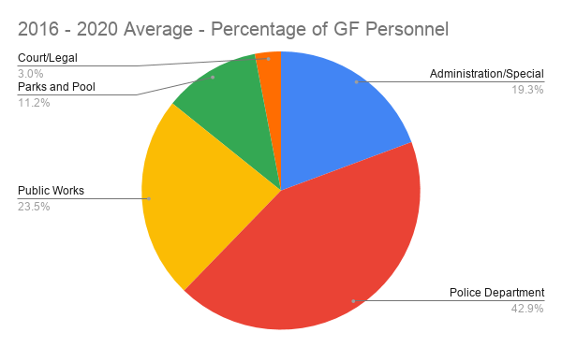
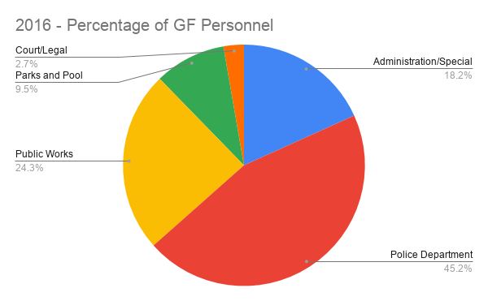

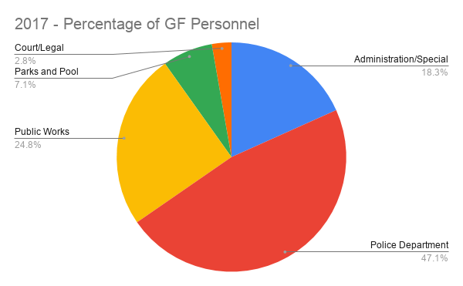
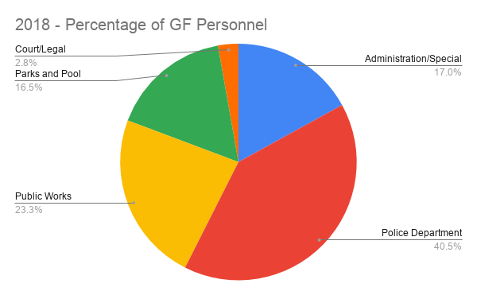

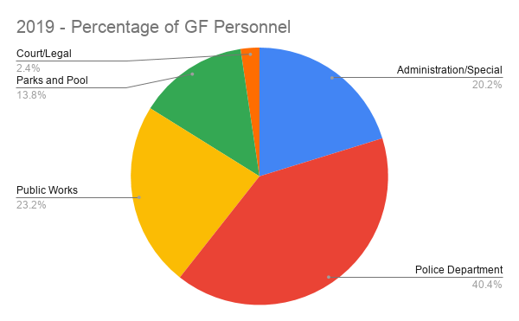
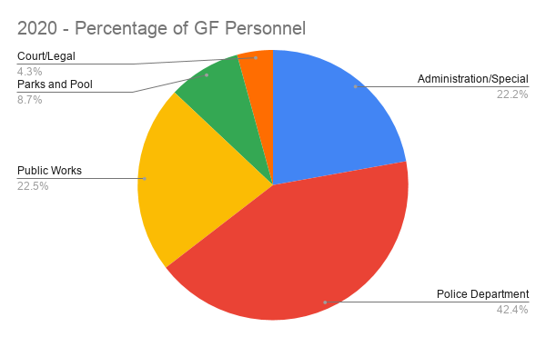

General Fund Operating Expense:

Category/Year | 2016 | 2017 | 2018 | 2019 | 2020 | Average
Administration/Special Projects | $74,931.00 | $71,901.00 | $200,339.00 | $66,412.00 | $84,964.00 | $99,709.40
% OE | 32% | 37% | 57% | 28% | 35% | 40%
Police Department | $23,417.00 | $47,777.00 | $41,818.00 | $25,220.00 | $49,617.00 | $37,569.80
% OE | 10% | 24% | 12% | 11% | 21% | 15%
Public Works | $120,390.00 | $55,480.00 | $66,888.00 | $104,748.00 | $75,029.00 | $84,507.00
% OE | 51% | 28% | 19% | 44% | 31% | 34%
Parks and Pool | $15,427.00 | $14,999.00 | $36,865.00 | $35,750.00 | $24,334.00 | $25,475.00
% OE | 7% | 8% | 11% | 15% | 10% | 10%
Court/Legal | $1,676.00 | $5,757.00 | $3,482.00 | $3,270.00 | $5,812.00 | $3,999.40
% OE | 1% | 3% | 1% | 1% | 2% | 2%
Total | $235,841.00 | $195,914.00 | $349,392.00 | $235,400.00 | $239,756.00 | $251,260.60

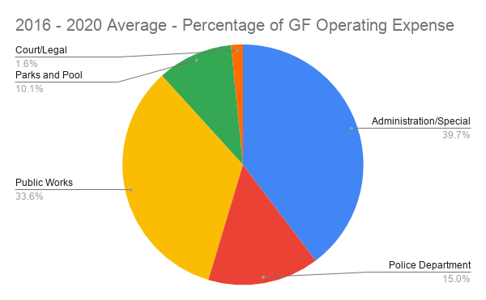
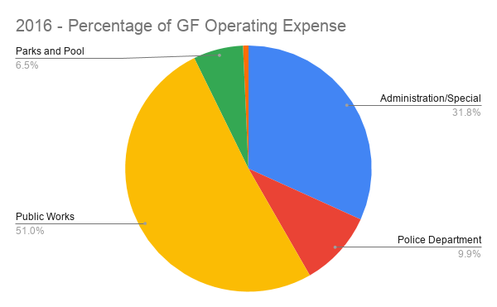
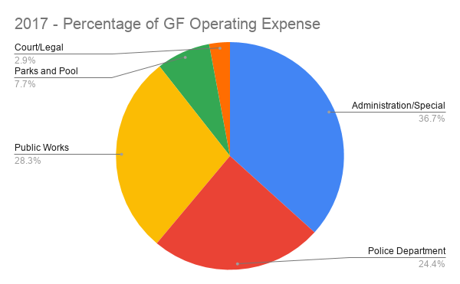
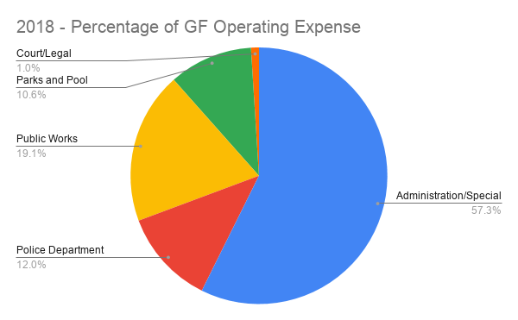
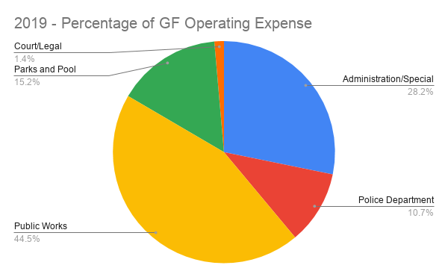
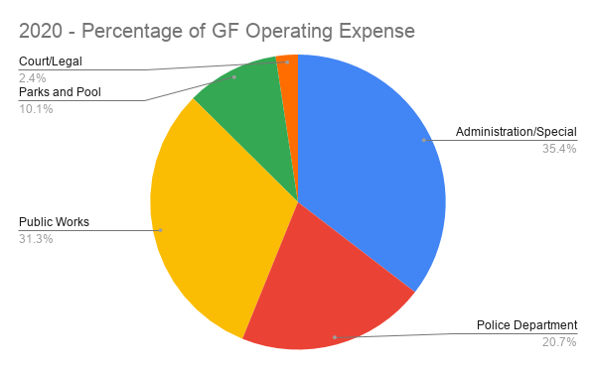
General Fund Combined Personnel and Operating Comparison:

Category/Year | 2016 | 2017 | 2018 | 2019 | 2020 | Average
Administration/Special Projects | $131,004.00 | $130,236.00 | $259,448.00 | $144,113.00 | $173,683.00 | $167,696.80
% GF | 24% | 25% | 37% | 23% | 27% | 28%
Police Department | $162,343.00 | $197,990.00 | $182,557.00 | $180,347.00 | $219,119.00 | $188,471.20
% GF | 30% | 38% | 26% | 29% | 34% | 31%
Public Works | $195,067.00 | $134,559.00 | $147,825.00 | $194,017.00 | $165,010.00 | $167,295.60
% GF | 36% | 26% | 21% | 31% | 26% | 28%
Parks and Pool | $44,756.00 | $37,599.00 | $94,256.00 | $88,682.00 | $59,117.00 | $64,882.00
% GF | 8% | 7% | 14% | 14% | 9% | 11%
Court/Legal | $10,061.00 | $14,540.00 | $13,165.00 | $12,332.00 | $22,925.00 | $14,604.60
% GF | 2% | 3% | 2% | 2% | 4% | 2%
Total | $543,231.00 | $514,924.00 | $697,251.00 | $619,491.00 | $639,854.00 | $602,950.20

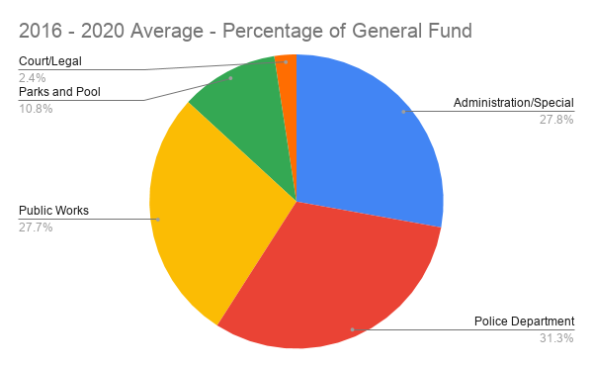
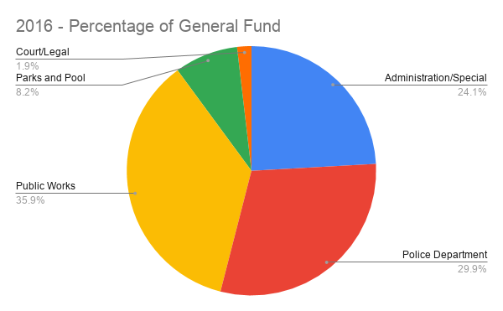
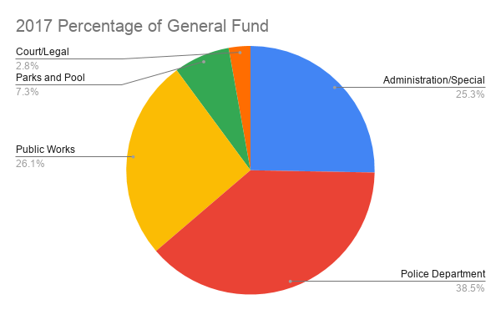
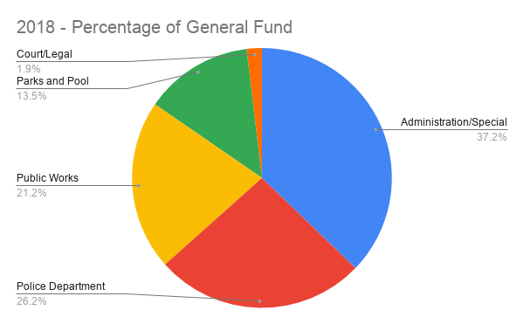
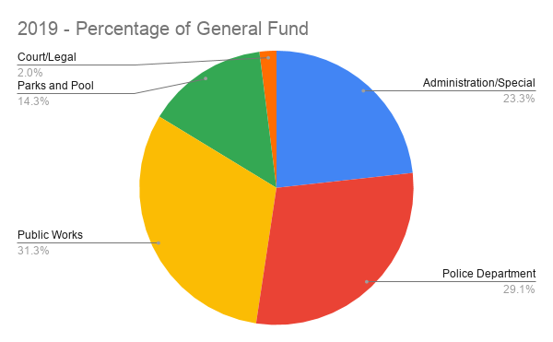
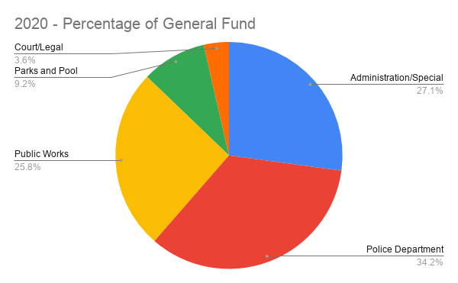
Other Funds:

Water Fund Income and Expenses
Year | Water Fund Total Income | Water Fund Total Expenses
2016 | $197,641.49 | $177,535.05
2017 | $197,027.99 | $166,069.64
2018 | $212,833.29 | $181,535.54
2019 | $205,681.04 | $220,548.86
2020 | $292,484.08 | $215,959.42
Total | $1,105,667.89 | $961,648.51
Average | $221,133.58 | $192,329.70

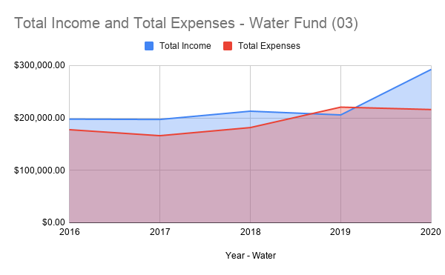

Sewer Fund Income and Expenses
Year | Total Income | Total Expenses
2016 | $126,135.65 | $121,436.47
2017 | $126,290.07 | $92,303.00
2018 | $130,357.91 | $120,459.00
2019 | $139,617.66 | $147,512.55
2020 | $138,921.57 | $125,058.00
Total | $661,322.86 | $606,769.02
Average | $132,264.57 | $121,353.80

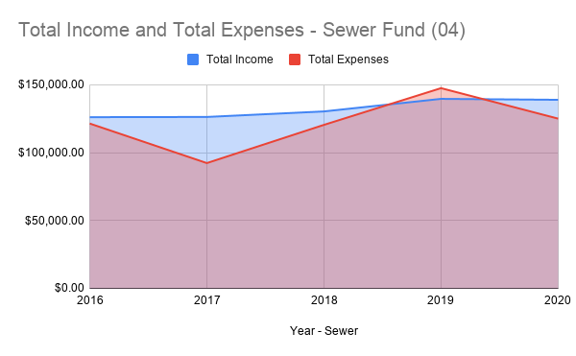
Debt:

Below you will see the debt payments for the City, over the last five years. In 2019, the payment on the Water Plant was completed. Going forward from 2020, the only debt obligation will be to the Swimming Pool G.O. Bond. This debt obligation will not count against the total debt limit of the City – opening doors for USDA loans for infrastructure projects.

All Funds, Percentage of Debt Comparison
Year | All spending | Debt payments | Non-debt spending | % Debt
2016 | $1,102,510.02 | $86,820.46 | $1,015,689.56 | 7.87%
2017 | $1,987,518.17 | $72,777.69 | $1,914,740.48 | 3.66%
2018 | $2,240,813.48 | $120,172.96 | $2,120,640.52 | 5.36%
2019 | $1,207,152.01 | $124,230.31 | $1,082,921.70 | 10.29%
2020 | $1,294,146.00 | $107,842.50 | $1,186,303.50 | 8.33%
*2021* | $1,400,000.00 | $105,867.45 | $1,294,132.55 | 7.56%
Total | $9,232,139.68 | $617,711.37 | $8,614,428.31
Average | $1,538,689.95 | $102,951.90 | $1,435,738.05 | 7.18%

The City is on track to reach the saturation point of the GO terms by 2033. The estimates I have included in the following table are conservative, so there is a reasonable chance this date comes before 2033.

Debt Schedule/Projections
Year | Income | Expense
2016 | $153,720.70 | $0.00
2017 | $100,807.70 | $41,458.23
2018 | $113,506.17 | $88,853.50
2019 | $138,218.90 | $108,687.50
2020 | $124,099.80 | $107,842.50
2021 | $120,000.00 | $105,867.45
2022 | $120,000.00 | $104,762.40
2023 | $120,000.00 | $103,527.40
2024 | $120,000.00 | $107,107.40
2025 | $120,000.00 | $105,497.45
2026 | $120,000.00 | $103,747.40
2027 | $120,000.00 | $106,787.40
2028 | $120,000.00 | $104,612.40
2029 | $120,000.00 | $107,187.40
2030 | $120,000.00 | $104,587.40
2031 | $120,000.00 | $106,906.20
2032 | $120,000.00 | $104,037.50
2033 | $120,000.00 | $105,975.00
2034 | $120,000.00 | $102,825.00
2035 | $120,000.00 | $104,468.70
2036 | $120,000.00 | $105,812.40
2037 | $120,000.00 | $106,968.70
Total | $2,670,353.27 | $2,137,519.33
Act. Average | $126,070.65 | $101,786.63

Infrastructure Spending:

All Funds, Percentage of Infrastructure Spend Comparison
Year | All spending | Infrastructure Spend | Non-infrastructure spending | % Infrastructure spending
2016 | $1,102,510.02 | $75,714.36 | $1,026,795.66 | 6.87%
2017 | $1,987,518.17 | $432,621.29 | $1,554,896.88 | 21.77%
2018 | $2,240,813.48 | $223,140.09 | $2,017,673.39 | 9.96%
2019 | $1,207,152.01 | $83,669.16 | $1,123,482.85 | 6.93%
2020 | $1,294,146.00 | $132,018.85 | $1,162,127.15 | 10.20%
*2021* | $1,400,000.00 | $370,000.00 | $1,030,000.00 | 26.43%
Total | $8,129,629.66 | $1,241,449.39 | $5,858,180.27
Average | $1,538,689.95 | $219,527.29 | $1,319,162.66 | 13.69%

Infrastructure Spend by Type
Year | Streets | Water | Sewer | Total
2016 | $64,539.17 | $0.00 | $11,175.19 | $75,714.36
2017 | $424,548.14 | $0.00 | $8,073.15 | $432,621.29
2018 | $191,889.74 | $0.00 | $31,250.35 | $223,140.09
2019 | $27,726.57 | $25,324.97 | $30,617.62 | $83,669.16
2020 | $96,197.59 | $28,100.00 | $7,721.26 | $132,018.85
**2021** | $120,000.00 | $120,000.00 | $130,000.00 | $370,000.00
Total | $860,362.04 | $173,424.97 | $207,662.38 | $1,241,449.39

Vehicle Replacement:

The City has been paying for major equipment and vehicle replacements out of the General Fund. When considering this over time, this becomes a very difficult practice, in terms of financial planning.

The State of Kansas allows the City to maintain and utilize a Special Equipment reserve fund, which can be used for Equipment/Vehicle replacement activities. Please refer to attachment 3 to see the roster of City equipment/vehicles, along with an estimated lifespan and replacement schedule.

Since the City has been using the General Fund primarily for acquisitions, the Special Equipment Reserve has been a dormant fund. I strongly encourage the governing body to change this practice. The City is behind schedule on saving to replace vehicles. If the City were to replace the vehicles, based on their estimated remaining lifespan, we would need to start off by transferring $53,291.67 this FY, slowing decreasing over the next decade. This is most likely not an option for the City at this time.

Please refer to this scenario if the City begins transferring $25,000 this year:

2021 Breakdown
Income |  | Expenditures
Starting Balance | $5,500.00 |  | $0.00
Transfer In | $25,000.00 |  | $0.00
Surplus | $0.00 |  | $0.00
 | $0.00
Total | $30,500.00 | Total | $0.00
End of year result |  | $30,500.00

2022 Breakdown
Income |  | Expenditures
Starting Balance | $30,500.00 | Police Vehicle | $22,000.00
Transfer In | $25,000.00
Surplus | $1,000.00
 | $0.00
Total | $56,500.00 | Total | $22,000.00
End of year result |  | $34,500.00

2023 Breakdown
Income |  | Expenditures
Starting Balance | $34,500.00 | City Admin PC | $2,500.00
Transfer In | $25,000.00 | PW Vehicle | $15,000.00
Surplus | $1,000.00 |  | $0.00
 | $0.00
Total | $60,500.00 | Total | $17,500.00
End of year result |  | $43,000.00

2024 Breakdown
Income |  | Expenditures
Starting Balance | $43,000.00
Transfer In | $25,000.00 |  | $0.00
Surplus | $0.00 |  | $0.00
 | $0.00
Total | $68,000.00 | Total | $0.00
End of year result |  | $68,000.00

2025 Breakdown
Income |  | Expenditures
Starting Balance | $68,000.00 | PD Vehicle | $22,000.00
Transfer In | $25,000.00 | PD PC | $2,500.00
Surplus | $2,000.00 | PW Mower | $9,000.00
 | $0.00 | PW Mower | $9,000.00
Total | $95,000.00 | Total | $42,500.00
End of year result |  | $52,500.00

2026 Breakdown
Income |  | Expenditures
Starting Balance | $52,500.00 | PW Vehicle | $15,000.00
Transfer In | $25,000.00 | PW PC | $2,500.00
Surplus | $1,000.00 | City Clerk PC | $2,500.00
 | $0.00
Total | $78,500.00 | Total | $20,000.00
End of year result |  | $58,500.00

2027 Breakdown
Income |  | Expenditures
Starting Balance | $58,500.00 | PD Vehicle | $22,000.00
Transfer In | $25,000.00 | Copier | $9,000.00
Surplus | $1,000.00 |  | $0.00
 | $0.00
Total | $84,500.00 | Total | $31,000.00
End of year result |  | $53,500.00

2028 Breakdown
Income |  | Expenditures
Starting Balance | $53,500.00 | PD Vehicle | $22,000.00
Transfer In | $25,000.00 | PW Vehicle | $15,000.00
Surplus | $4,000.00 | Dump Truck | $20,000.00
 | $0.00
Total | $82,500.00 | Total | $57,000.00
End of year result |  | $25,500.00
2029 Breakdown
Income |  | Expenditures
Starting Balance | $25,500.00 | City Admin PC | $2,500.00
Transfer In | $25,000.00 | Backhoe | $40,000.00
Surplus | $2,000.00
 | $0.00
Total | $52,500.00 | Total | $42,500.00
End of year result |  | $10,000.00

2030 Breakdown
Income |  | Expenditures
Starting Balance | $10,000.00 | Tractor | $40,000.00
Transfer In | $25,000.00
Surplus | $2,000.00
 | $0.00
Total | $37,000.00 | Total | $40,000.00
End of year result |  | -$3,000.00

2031 Breakdown
Income |  | Expenditures
Starting Balance | -$3,000.00 | PD Vehicle | $22,000.00
Transfer In | $25,000.00
Surplus
 | $0.00
Total | $22,000.00 | Total | $22,000.00
End of year result |  | $0.00

This is a hypothetical scenario; however, you can see that is plausible. We have a roster of mostly aging vehicles and equipment, which will need attention. If the governing body wishes to maintain this amount of equipment and vehicles, I strong recommend $25,000 as a minimum transfer amount to the Special Equipment Reserve Fund.

The Public Works department is largely able to complete maintenance in-house. There are some repair costs, however, they are hit and miss compared to the Police Department who regularly seeks maintenance on vehicles given the patrol hours. Please see the maintenance history on PD vehicles the last two years:

Vehicle | 2019 | 2020 | Total
2010 Dodge Charger | 604.62 | 84.16 | 688.78
2008 Jeep | 2192.94 | 2032.34 | 4225.28
2014 Dodge Charger | 280.38 | 479.6 | 759.98
2018 Ford Explorer |  | 967.62 | 967.62
Total | 3077.94 | 3563.72 | 6641.66
Insurance is another cost that is incurred annually per vehicle:

Department | Equipment | 2020 Insurance | 2021 Insurance
Police | 2010 Dodge Charger | $768.00 | $703.00
Police | 2008 Jeep | $607.00 | $634.00
Police | 2014 Dodge Charger | $947.00 | $926.00
Police | 2018 Ford Explorer | - | $1,247.00
Public Works | 2001 Dodge | $607.00 | $558.00
Public Works | 2010 Chevy | $795.00 | $756.00
Public Works | 1994 Chevy | $346.00 | $326.00
Public Works | 2006 International Dump Truck | $1,253.00 | $1,360.00
Total |  | $5,323.00 | $6,510.00

ISSUES:
1. General fund 12 month rolling average is short of desired three month emergency reserve amount.
2. Vehicle and equipment replacement is a looming challenge. These expenses have historically hindered the General Fund.
3. Begin discussions on discretionary spending for 2021 general fund. Ideally wait until June to expend resources. Once the governing body gives direction on spending priorities, staff will begin making preparations to hold more detailed discussions at later meetings.

Proposed Item | Estimated cost | Rank
Oak street pond | $25,000.00
Jeep Liberty Replacement | $22,000.00
Police Department and Public Works Department building Maintenance/renovation | $15,000.00
House Demolition | $10,000.00
Swimming pool parking lot | $25,000.00
Swimming pool driveway | $6,000.00
ADA accessibility of City Hall | $5,000.00
Police Department Case Management Server | $3,500.00
Chevy 1500 Replacement Truck for Public works | $15,000.00
Ordinance Codification | $10,000.00 | 3
Benches and trash receptacles for downtown | $5,000.00
Rock/sand/salt and dumpster area | $10,000.00 | 2
VERF Contribution (Special Equipment Reserve Transfer) | $25,000.00 | 1
Total | $151,500.00

- Numbers in the ranking column are my recommended priorities for the coming year.
- Final number of discretionally spending will not be able to be determined until after at least June, when second round of significant property taxes are deposited. If revenues drop of, it will need to decrease.

RECOMMENDATION:

Begin end-of-year transfer from General fund to Special equipment reserve.
Identify the spending priorities of the governing body.

Sincerely,

Joseph Hackney
City Administrator

