City Administrator Report

May 4, 2020

Dear Mayor and Members of the City Council:

Discussing the 2020 Swimming Pool season will be a key item this meeting.

I have polled surrounding (more similar in size than Topeka) communities with swimming pools. Here are the results:

Atchison: Not opening.
Effingham: Not opening.
Holton: Not opening.
Oskaloosa: Meets May 7th.
Wamego: More information presented at the City Council meeting.
Tonganoxie: More information presented at the City Council meeting.

What the City Council ultimately decides to do is fine with staff, and we will carry these orders out effectively. Nevertheless, I strongly advise you to not treat this swimming pool season like any other. The only way that opening the swimming pool can be safely accomplished from a fiscal and public health standpoint is to 1) substantially limit the number of people allowed at the pool at any one time; 2) Only hire essential levels of staffing (i.e. Maximum 15 staff members, plus two managers) 3) implement very strict sanitization and screening measures. For example, regular cleaning during a set amount of time each hour and limiting the number of people in the bathroom, on the deck, etc. Also, mandatory temperature screening must happen at the point of entry into the swimming pool. Staff can explore contactless options. Right now, I have priced these devices at around $80 - $150.

Once again, I understand that the swimming pool is a fantastic element of this community. This pool is something that the community should be very proud of; I know I am proud to show it to my friends and family. Please keep in mind the serious repercussions if an outbreak occurs, or if there is a significant drop in revenue due to low attendance. Covid-19 is not fair for people, especially kids, who simply want to enjoy life. We want to provide a great public service which enriches this community, however, we are responsible for setting standards to protect the fiscal health of the organization, and the physical health of the community.

Staff conducted a survey (153 respondents, closed Monday 5/4) to identify the views of community members on opening up this season:

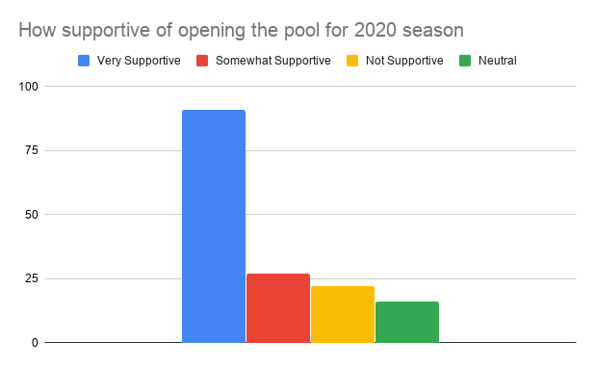

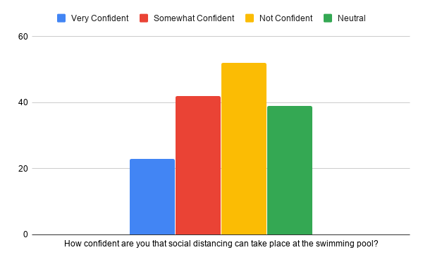

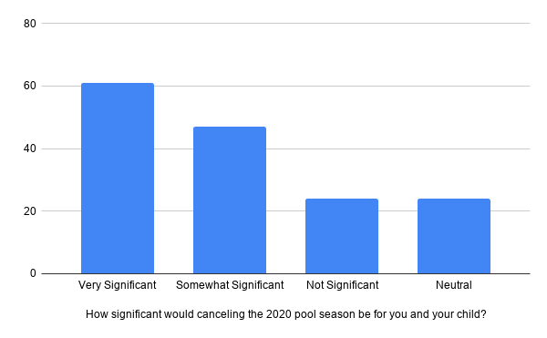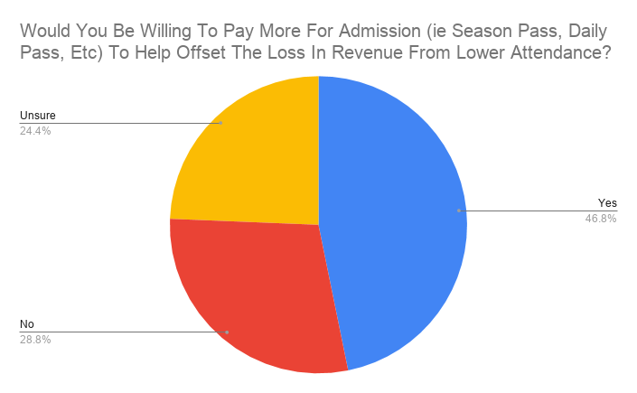

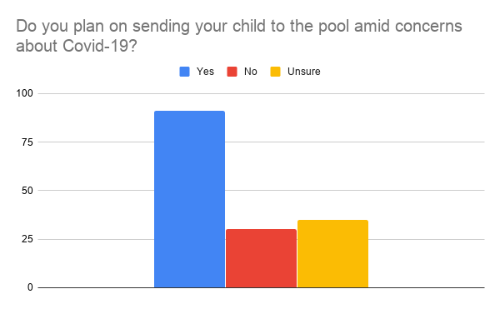

What specific safety precautions would make you more comfortable sending your child to Valley Falls pool this year?

We have a pool so I will be keeping them here.
There is no evidence that the virus that causes COVID-19 can be spread to people through the water in pools, hot tubs, spas, or water play areas. Proper operation and maintenance (including disinfection with chlorine) of these facilities should inactivate the virus in the water.
The facility may need to enhance their cleaning procedures.
I'm not worried that the facility would be a breeding ground for the COVID-19. You could have a normal season and never have an issue. However, I could change that opinion once there was a confirmed case in the City.
If you must practice social distancing---then I wouldn't sell any season passes. Make it all general admission. Not fair to sell a season pass and have the chance of never being able to use it.
Aside from limiting how many people are at the pool I'm not sure.
My child was only one there. Didn’t want this damn thing anyway
It is too early to lift the social distancing precautions
None do not open
Reduce occupancy to an acceptable level.
As much as I want you to open, I still think it’s not a good idea.
Limiting the number of people allowed in and enforcing social distancing.
Honestly probably none
Not sending him!
Not send them
There are so many unattended children that there is no way safety precautions would help. Everyone us supposed to shower before entering the pool, but that is not even enforced and no one does that.
I think the kids will gather together and no matter how much cleaning you do they will spread this virus
No one else in the pool, have it all to ourselves
Limit how many people allowed in pool area
THERE IS NO WAY FOR ANYONE TO WEAR A MASK AND SWIM. THERE IS NO WAY A BUNCH OF KIDS ARE GOING TO STAY 6-10 FEET AWAY FROM EACH OTHER. AND EVERYONES TEMPERATURE SHOULD BE TAKEN EVERY 4 HRS AND WITH SWIMMING AND IN THE HEAT WILL ANY OF THOSE TEMPS BE ACCURATE. AND MOST KIDS ARE GOING TO POSS LIE ABOUT SYMPTOMS JUST THEY CAN STILL GO. COME ON PPL. USE YOUR HEAD AND BRAINS. THIS IS A REAL VIRUS. THERE ARE REAL PPL GETTING AND DYING. YES THERE ARE SOME RECOVERING BUT THOSE DYING ARE ALONE. NOONE AT ALL WITH THEM. AND THE LAST QUESTION SHOULD BE SUBSIDIED BY THE CITY. CTY. STATE ETC.
none
There is no way to social distance at a pool. Not sure it would be worth it for the City of Valley Falls to be responsible for an outbreak.
Nothing. I’m typically a positive person but I’m afraid things, overall are being opened too quickly. Not worth the liability
Cap on number of people, proper cleaning of all surfaces on a regular schedule all day long and social distancing.
There is none. They don't want to swim by their self so they would gather.
Not opening.
Social distancing, the virus living on surfaces for hours/day
Not sure. I don't have kids but grandkids. I would leave that decision to my son and his wife.
N/a
There is no way to enforce social distancing in such a place, especially with children, they cannot help themselves.
I’m honestly not sure. I don’t think that children can safely follow any distancing guidelines or sanitation guidelines especially due to the fact that a large amount are there unsupervised all day.
Limited number of people admitted.
Limit the number of patrons a day so it’s not overly crowded
None
None unless virus is gone
Children under 15 accompanied by an adult
Regular Half hour disinfectant wipe downs of counters & restrooms
I don't have children that are pool age, but we, as a society, have overreacted to the virus situation. We need to get back to just opening things back up.
Not opening until at least June 15th if state restrictions have been lifted and social distancing guidelines given from KDHE. Day cares should be surveyed as they make up a lot of the attendance.
Reduced number of swimmers at the same time, sanitizing frequency, spacing of seating and swimmers
Limit on swimmers
6 foot distance but unsure how that will work in a pool
Only allowing so many at a time
Idk what precautions could be taken at the pool. There's no way that kids will social distance there.
I would be ok with the kids going to the pool this summer but probably not likely right away but maybe later in the summer.
Lowered occupancy. Swim breaks for cleaning.
Limited number of people with a hour limit they can be there and social distancing. And cleaning of all surfaces several times a day.
Taking temperature before entering.
Cant think of any
No sick kids at the pool.
Making sure the occupancy is kept to a minimum.
Unsure....maybe limited numbers each day?
I'm unsure without doing more research how much of a risk being at a chlorinated pool really poses....
Ensuring that the appropriate number of people considering the social distancing and limit at the time are admitted.
Unsure
Limiting the number of people at the pool at a time, more cleaning
Unsure
Extra cleaning if possible. I feel like it would be hard to make all of the kids actual social distance though.
If someone was exhibiting any sort of symptoms, deny entrance
More workers to monitor and ensure social distancing
I think opening later would make me more comfortable. I’m not supportive of memorial weekend, but maybe halfway through June, possibly beginning of July! That way we can really see what comes of lifting social distancing and other guidelines.
Not sure at this point
None
Limiting the amount of people swimming
The pool does a great job keeping things clean. Maybe wiping off chairs when people leave. It is more about numbers and how the curve goes once people start going out more. Will people send their kids sick? Will people try to socially distance?
Need more info on whether or not the virus can spread through water? Would chemicals destroy the virus if it’s in the water?
Unknown
Cleaning by adults
Unsure at this point in time
Everything would need cleaned regularly. Have staff just for that along with lifeguards doing their normal thing.
Limited people
Monitor social distances
We feel safe sending our kids knowing the staff will be sanitizing bathrooms and countertops and other surfaces where the virus could be spread from.
No concerns
social distancing
I'm not sure how to answer this question. Confident the staff will do all they can. Kids love swimming and horesplaying with friends so the thought of lifeguards having to try and keep kids apart would be miserable, so I hope the COVID-19 cases continue to drop so we can resume some normal summer fun.
No
None. Let nature run its course.
None
None
?
Only letting in 50% of the occupancy
As long as they are cleaning on a daily basis and make sure all food is clean it should be fine
As for the ? Of paying more I don’t understand why we would have too it’s been closed during this pandemic so what would be the more money for
I'm not sure if there is anything more that you can do? Maybe spraying down chairs and tables to sanitize, although I would think the sun would eliminate this need.
N/A
Hand washing stations
Idk
that they all stay there distance away from each other. maybe check for fevers when they enter.
Sanitizing of the equipment each night after close or having a mid day break to clean and then clean again at close. Keep chairs 6 ft apart. Hand sanitizer on hand.
Limited number of people at a time
Regular cleaning
None. No one knows how to wear face masks or gloves correctly. The sunlight kills the virus and kids are not getting sick from this. Stop fear mongering and let this children have their childhood back.
Not sure
Social distance
Extra cleaning of touched surfaces, including lounge seats and tables. Frequent wash off of concrete, including bathroom and entrance.
Depends on when they open and the state of the virus.
Na
Normal cleaning procedures
Bleaching and sanitizing surfaces much more frequently.
Cleaning bathrooms every hour (like handles to doors, toilets, sinks) anywhere frequently touched.
As long as common sense precautions take place I feel the swimming pool is one of the safest places for our youth to be this summer. With so many activities being cancelled this summer it is going to be important for the library and pool be available to keep kids busy and making good decisions on how to spend their time. The pool also serves as a check in location for parents monitoring their youth. Parents are overwhelmed with job restructuring and a place for kids to be helps. It’s also an opportunity for children to be seen in a community that is watching to ensure that our kids are safe.
None
Take the temperature of everyone who enters to make sure that they are okay. Sanitize daily.
Not really any by the time you open, by June 1, 90 people can be at gatherings!!!
Lower number of occupancy. Disinfecting of indoor surfaces.
Just making sure that the chairs and everything is wiped down every so often after people use them.
Extra cleaning breaks for staff wipe down surfaces that get touched
Extra cleanliness in bathrooms. Heat and bleach kill the virus, so the pool will be one of the best places to be!
Cleaning surfaces in the building more often. Twice an hour on a rotation.
N/A
I'm counting on the chlorine in the pool to take care of sanitation.
Limiting capacity
Extra sanitation efforts
Keep the public areas clean just as you always do/have done in the past.
Provide soap in bathrooms
Increase cleaning
Sanitize. Sanitize. Sanitize.
Na
Limiting the number of people allowed inside and around the pool. I would also set limits on the amount of time each individual can spend at the pool each day if there are people waiting to get in.
I feel the manager and guards will take every needed precaution..
..
Limit capacity and extra cleaning
No concerns
Extra cleaning requirements
N/a
I wonder about considering opening primarily for swimming lessons and private parties (more of them/offered throughout the day) so people have more control over who they have contact with.
Limits on the number of people allowed to enter the pool
I can’t think of anything
N/A
None
Cleaning all door handles, ladders, and railings frequently throughout the day.
Maybe keep number of admissions down
Na
None
Sanitizing of pool equipment and toys
None. The overall concern for children getting COVID-19 is very low. Elderly should take precaution as necessary.
Follow KDHE guidelines.
Just make sure employees are diligent about washing their hands.
Making sure kids Aren’t sick, maybe having the age where parent is required to be increased.
NA
I feel the staff will adequately make preparations and maintain the sanitization of the facilities. Therefore I have no concerns.
Would you check temperatures before kids entered
Sanitizing as much as possible
Separate area for eating maybe.
Making sure the water fountain and things get disinfected not just hosed down
Gloves or sanitizer at concession stand, frequented cleanings of restroom, and other common areas
None
Not sure
Allowing only valley falls citizens to use the pool or Valley Falls students/staff
Not sure. I suppose that, keeping a safe distance for lines with the slide, concessions stand etc. would be good. Initiating some procedure or putting a reminder of 6ft space in restrooms and changing areas would be good. Would really hate to see the kids miss out on the normal summer activities when most of us have probably already had it.
Hand sanitizer available
Social Distancing
Have an active hygiene policy to keep the bathrooms and counters clean
N/a
More wiping down of chairs, areas where people sit.
Unsure.
Only allow VF residents to buy a season pass, and that is the only way to get in pool is with a pass. Temperature check on anyone entering,
Wait until everything is open fully. Maybe a shortened pool season. Would be open to some restrictions depending on the situation with cases. If things get worse, then yes I can see not opening the pool.
If it is packed, we won't stop.
Limiting how many people in each section of the pool.
Limited number of people at pool at any given time

Other information…

Municipal Court has been postponed until May. Understandably, this has put a lot of cases on hold. We will begin new Health and Welfare Code Enforcement inspections the end of May.

We are planning on having Agler & Gaeddert complete the on-site portion of their annual audit the second meeting in May.

I will be reaching out to each of you sometime in the next month to schedule City Council tours of the Police Department, and Swimming pool facility. This will be completed prior to approving a budget for FY2021. More information to come.

I received a call from a regional FEMA representative regarding disaster reimbursement. The agent indicated they were trying to meet a quick deadline of June for category A and B flood damage. After discussing this, Valley Falls was determined to have category F flood damages. In short, the City is going to be waiting a while to recover financial damages from the 2019 floods.

Public Works Director Chad Jepson and I will be interviewing candidates for summer help positions on Tuesday, May 5. More information will be presented at the council meeting.

The dangerous structure at 281 Maple Street has been demolished:

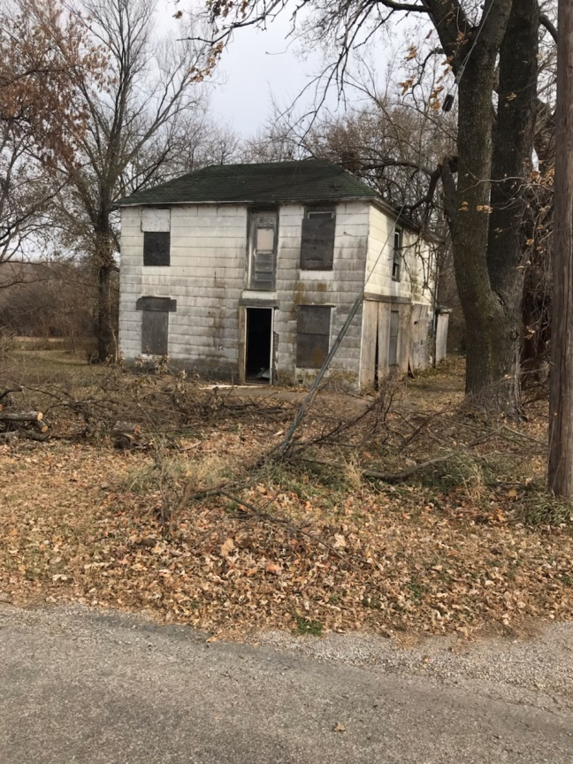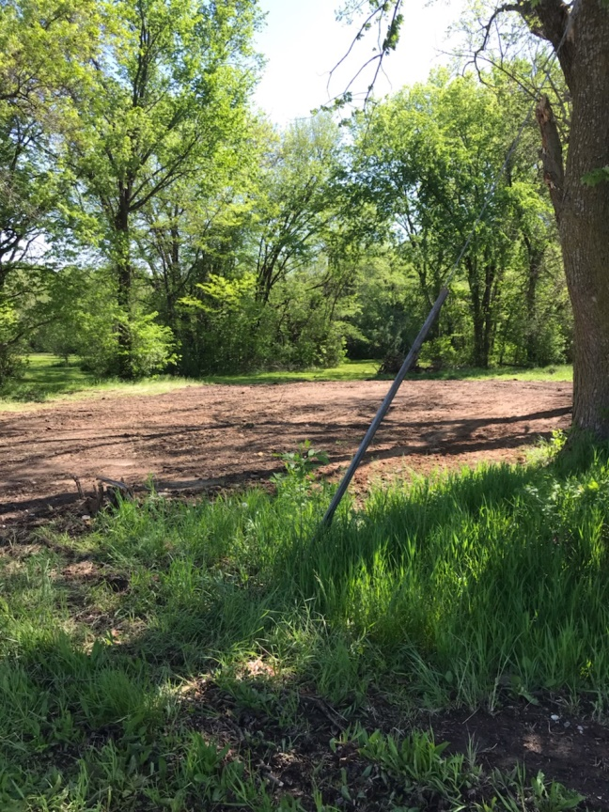

As a result of the last council meeting:

Staff has completed an ordinance which would accomplish proposed changes to Council meetings.

Planning and Zoning Board:
There is a vacancy on the Planning and Zoning board.

Meetings recently attended included: Department Heads, meetings with Council Members, KACM Conference Calls, League of Kansas Municipalities Conference Calls, City Attorney, Watson Development, meeting regarding lots on Oak Street, Swimming Pool Manager and Assistant.

City Council Meetings, Study Sessions, and Executive Sessions
Tentative future City Council agendas include the following items at this time:

- FEMA Disaster Recovery application.
- Review of RFP bids for Street projects.
- Review of Audit results.

Code Enforcement Statistics:
This section will include a report of the number of cases currently in the code enforcement process, as outlined in City Ordinance. This section will be the analysis provided to the council, unless there is a practical application of discussing properties and/or owner name(s). (I.E. on the agenda, citizen complaint or public comment, need to approve expenditure above $500, etc.) Please advise if you have any questions about this, and/or have suggestions.

Code Enforcement Phase | # of Cases
Violation Observed/ Letter Pending: | 0
30 Day Notice Letter Sent | 3
30 Day Letter Re-inspect / 10 Day Letter Pending | 0
10 Day Letter Sent | 0
10 Day Letter Re-inspect / Review w/ Admin Hearing Officer/ Sent to Municipal Attorney | 1
Cases pending court | 5
NEKES
Cases Pending | 1  0 new cases  2 cases has been resolved

Website update:
This section will be a brief update on the progress being made on the website. Please review, and let me know if you have some suggestions.

Upload agendas
Upload minutes
Upload CA report

Planned items on website update:
Economic profile
Economic Development Committee
Mayor and City Council
City Financial Health Snapshot:

Updated reports are prepared for the last meeting of each month.

Please see the separate attachment:

Fund Balance:

Published Budget Status:
Published Budget w/ Cuts (-15%):
Income/Expenses (All funds):

