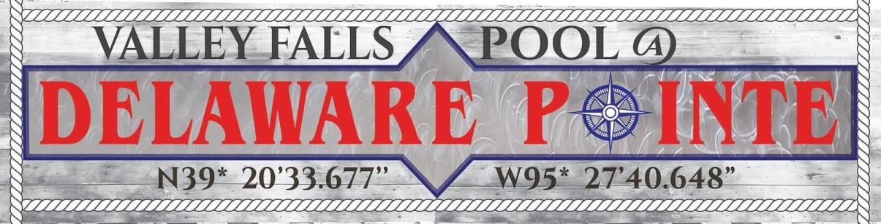

403 Francis St. - Valley Falls, KS - 785-945-3313
Open Friday, June 26, 2020
Plans to continue thru Labor Day
Open Daily: 12 to 7 p.m.
Come by the pool to sign up for swimming lessons or to buy a pass.
Call 785-945-3313 during pool hours for more information.

Daily Passes
(Valley Falls Residents)

Child (ages 5 & Under)…...$1.00
Student (ages 6-18)…………..$2.00
Adult………………………………$3.00
Seniors……………………………$2.50

10-Day Passes

Child (ages 5 & Under)…...$8.00
Student (ages 6-18)…………$18.00
Adults……………………………..$28.00
Seniors…………………………….$23.00

Daily Passes
(Non-Valle Falls Residents)

Child (ages 5 & Under)…...$2.00
Student (ages 6-18)…………..$3.00
Adult………………………………$4.00
Seniors……………………………$3.50

10-Day Passes

Child (ages 5 & Under)…...$18.00
Student (ages 6-18)…………$28.00
Adults……………………………..$38.00
Seniors…………………………….$33.00

Hour Time
10 people or under $75.00
11-25 attending $100.00
25-50 attending $150.00
50 or more $175.00

Hour and Half Time
10 people or under $110.00
11-25 attending $150.00
25-50 attending $225.00
50 or more $260.00

Pool Parties!

Public Lessons – Level 1-5 $40.00
Two weeks 40 minutes per class
Private Lesson - $60.00
Call 785-945-3313 for more information.

